Yowah Nut Opal

This Opal is also found in central Queensland (for example Yowah, 400 population).
The Yowah Nut is the most fascinating Opal for me !!!
The special thing about it is !!!
The Opal draws within a thin net through the ironstone and beautiful filigree multicolored markings occur (Yowah-Nut).
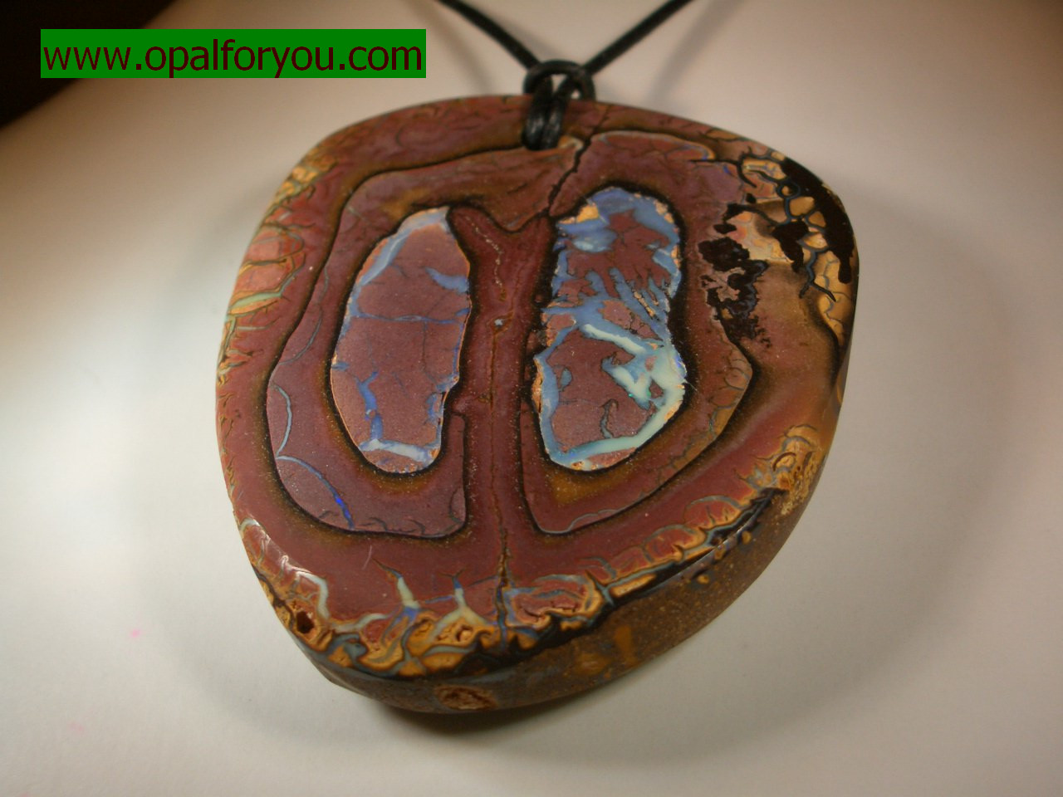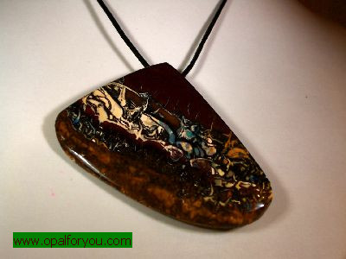

Matrix Opal
(Opal in Motherstone)

The Matrix Opal is very closely related to the Boulder Opal.
It contains less precious Opal but because of its multicolored
fire it’s very popular.

