Boulder Opal

The Boulder Opal is mined in Ironstone (ironstone boulders) in central Queensland. Mostly this Opal is found in very thin veins in the boulders (boulder rock).
The Boulder Opal is more robust than other Opals because the ironstone on the backside is left.
It is equal or even superior compared to most of the Opals in terms of play of color, liveliness and clearness.

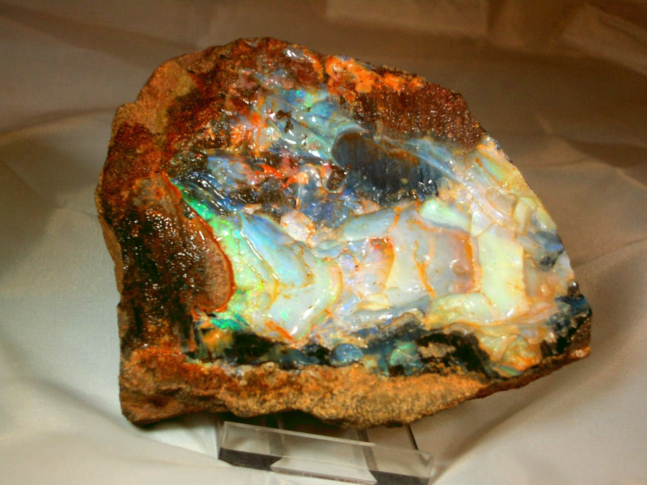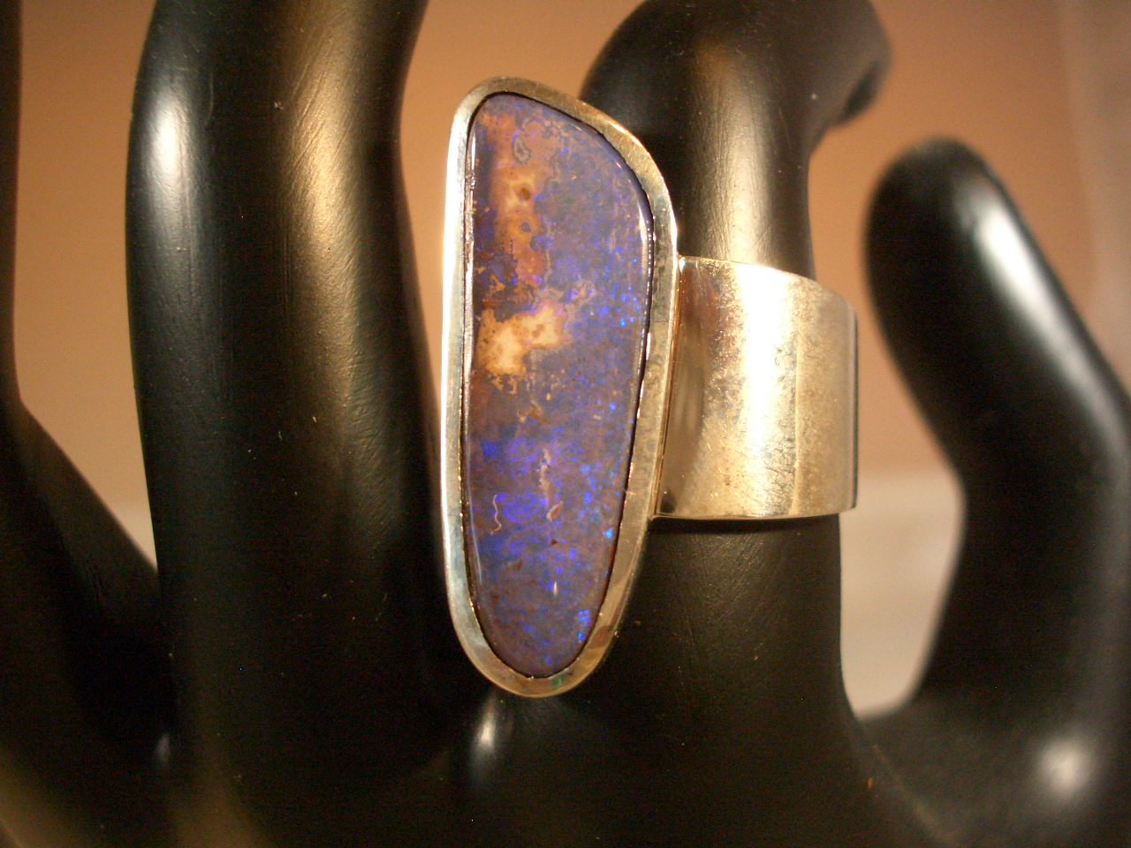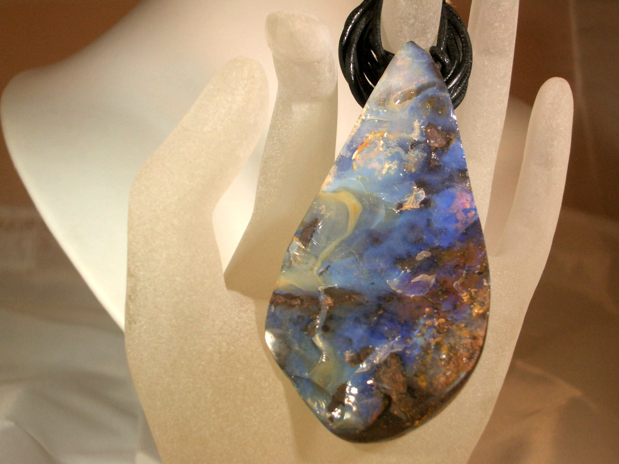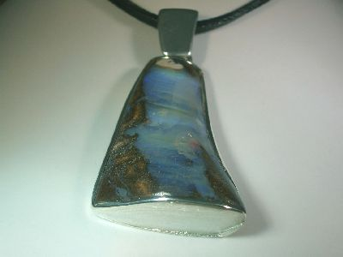

WWW.OPALFORYOU.COM

