The Opal as a healing crystal

Spirit and spiritual aspect: high spirits, good instinct, live perspectives, life-dream, will to live, humor, enjoyment and more

Soul or subconscious: makes extravert and helps infect others with one’s joy, brings exuberance and a deep feeling of joy, brings comfort during fear or grief, makes flexible and helps adjust to changing situations, stimulates day and night dreaming, brings quick recovery from exhaustion, lightens mood

Mind and mental aspect: inspires imagination, makes clever and creative, aids communication, for a good contact with the environment

Body or physical aspect: promotes regeneration, improves the auto-regulation of the whole organism, enhances the immune system and self-healing power, stimulates lymph flow, the kidneys and regulation of water balance, reduces fever, promotes blood flow

(Michael Gienger Healing Crystals The A-Z Guide to 430 Gemstones)

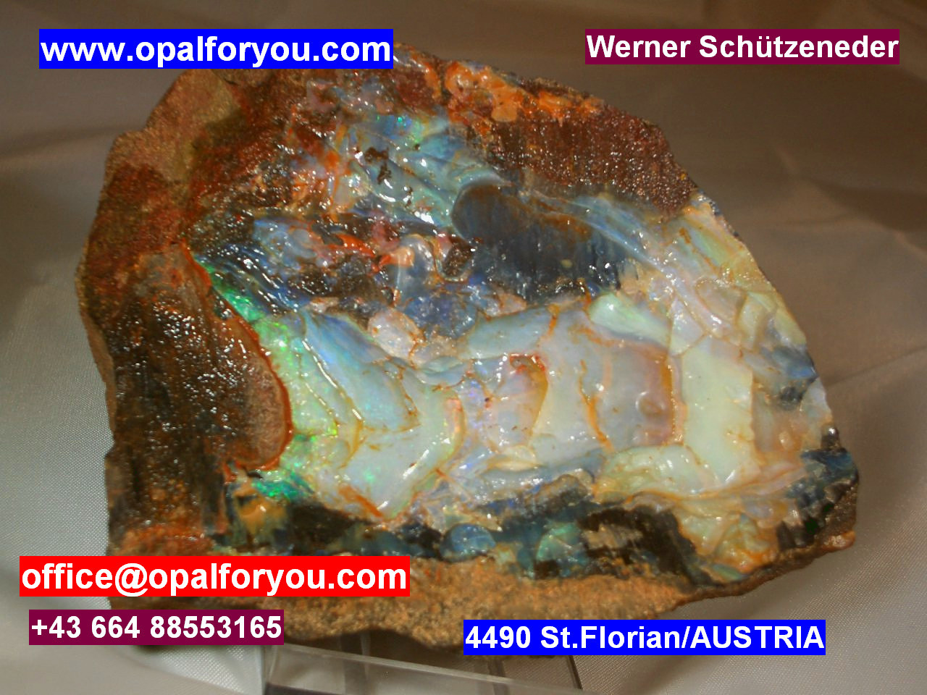

Lots of fun with your Opals wishes you Werner

